**THE URINARY SYSTEM**

The urinary system is the main excretory system and consists of the following:

* 2 kidney-secretes urine
* 2 ureters-Transports urine from the kidney to urinary bladder
* urinary bladder-collects and stores urine temporally
* Urethra- through which urine is discharged from urinary bladder to the external environment

**Functions of the urinary system**

a) Maintains balance of water and electrolyte in the body

b) Production of urine

c) Excretes wastes products i.e. nitrogenous compounds, urea, uric acid, excess ions and some drugs.

**THE KIDNEYS**

* These are two kidneys (right and left) located on the posterior abdominal wall .It is behind the peritoneum and below diaphragm.
* It extends from the 12th thoracic to 3rdlumbar, the ribs provide protection
* The right kidney is lowering located since above it is the position of the liver.
* The kidney is bean shaped 11cm long, 6cm wide, 3cm thick and 150 g weight.
* It is embedded in the mass of fat; renal fascia encloses the kidneys and renal fat.

**Organs associated with the kidney**

1) Right kidney

* Superior-the adrenal glands
* Anterior –right lobe of liver, colon
* Posterior-diaphragm muscles of the abdominal wall

2) Left kidney

* Superior -left adrenal gland
* Anterior-spleen, stomach, pancreas, jejunum, colon
* Posterior-diaphragm muscles of posterior abdominal wall

**Structure of the kidney**

The kidney is surrounded by capsule

The cortex reddish brown layer of tissue immediately below the capsule and outside the pyramid.

The renal pelvis is funnel shaped structure that acts like a receptacle for urine formed by the kidney

Calyces is the number of distance branches of renal pelvis

Formed urine in the kidney passes through the papilla the apex of pyramid into minor calyx, the major calyx before getting into ureters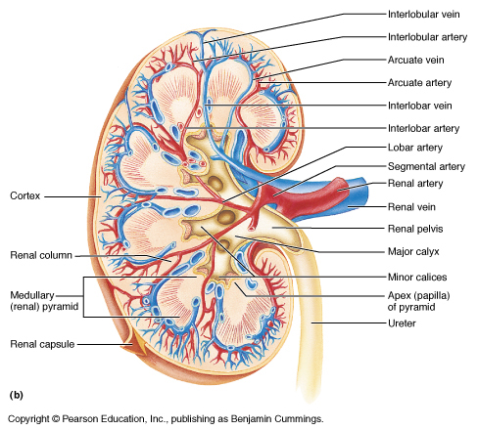.

**The microscopic structure**

The kidneys contain one million functional units the nephron and smaller number of collecting ducts transport urine through the pyramid to the renal pelvis giving them their stripped appearance. The tubules are supported by a small amount of connective tissues containing blood vessels. The nephron consist of a tubule closed on one end and the other one open the closed end is cup –shaped glomerular capsule(bowman’s capsule ).It encloses network of arteries(glomellular) 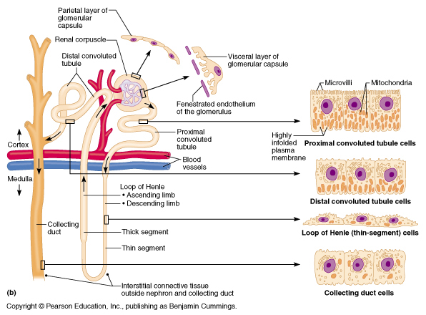

**Series of blood vessels in the kidney**

Branch of renal artery-Afferent arterioles-glomerulus (cluster of capillaries)-Efferent arterioles-capillary network supplying nephron-renal vein.

The outer part is 5cm long described as:

1. Proximal convoluted tubule

2. Medullary loop (loop of henle)

3. Distal convoluted tubule which is leading to the collecting tubule

**Series of blood vessels in the kidney**

Renal artery divides into afferent arterioles which enter each glomerular capsule then divides into cluster of capillaries forming glomerulus.

The efferent arterioles leads away from the gomeurlus.It breaks into secondary capillary networks and exchange across capillary wall which regulate the composition of blood and supplies local tissue with oxygen and nutrients.

Venous blood drained from this capillary bed and eventually leaves the kidney in the renal vein them to the inferior venacava

**Functions of the kidney**

1-formation and excretion of the urine

The process of urine formation involves filtration, selective reabsorption; tubular secrection.The urine is formed after filtration of blood in the kidney.

2. Water balance and urine output

The kidney balances between intake and output .In case of excess urine volume, antidiuretic hormone is secreted (ADH) by the posterior pituitary gland to reduce urine output.

When blood volume is high, stretch receptors in the atria of the heart produces Natriuretic hormone (NUH)which inhibits the reabsoprtion of sodium and water hence increasing the urine output.

3. Electrolyte balance

Change in the concentration of electrolytes in the body fluids may be due to change in:

* The body water content
* Electrolyte levels

There are several mechanisms that maintain balance of electrolytes

* Sodium potassium balance
* Calcium balance(calcitonin lowers calcium levels in blood while the parathyroid hormone increases

4.Ph balance

* In order to maintain the normal blood balance Ph (acidity balance) the cells of the proximal convoluted tubule secretes hydrogen ions to control the acid -base balance
  + production and secretions of erythropoietin (control red blood cells formation)
  + Production and secretion of rennin (control the blood pressure)
* Urine formation
* Excretion of waste product
* Regulation of electrolytes
* Regulation of acid–base balance
* Control of water balance
* Control of blood pressure
* Renal clearance
* Regulation of red blood cell production
* Synthesis of vitamin D to active form
* Secretion of prostaglandins
* Regulates calcium and phosphorus balance

**URETERS**

Ureters are tubes (ducts) that convey urine from the kidney to the urinary bladder. They are about 25-30cm long with a diameter of 3mm.

The ureter continuous with funnel –shaped renal pelvis it passes downwards through the abdominal cavity and to the posterior wall of bladder.

**Layers of the ureters**

i) Fibrous tissue: continuous with fibrous capsule of the kidney.

ii) Muscular layer: smooth muscle fibers

iii) Inner layer: mucosa (contains mucus)

**Functions of ureters**

It propels urine from the kidney into the bladder by peristaltic contraction of smooth muscle.

URINARY BALDDER

* It is the reservoir for urine. It lies in the pelvic cavity.
* T he size and shape varies depending on the volume of urine it contains

**Organs associated with the bladder**

* Superior-peritoneum surface
* Anterior-abdominal wall
* Posterior-uterus/rectum in men

**Layers of the bladder wall**

-The outer layer –contains loose connective tissue blood and lymphatic vessels and nerves

-Middle layer –mass of interlacing smooth muscle fibers and elastic tissue loosely arranged in 3 layers (detrusor) contracts to empty the bladder

-The mucosa-composed of transitional epithelium when bladder is empty ,inner layer is arranged in folds or reggae which disappears when it is full of urine.

-The bladder caries 300-400mls of urine rarely in carries 600mls .There are three (3) orifices which makes a triangle known as trigone .The two upper are from ureters and the one below the urethra.

**Urethra**

It is a canal extends from neck of bladder to the external urethra orifice.

In male the urethra is long and it’s associated with the reproductive system.

-in the male urethra is 4cm (down wards and forward) is located behind symphsis pubis

**Male urethral wall consists of**

* muscle layer-continuous from bladder and has smooth muscle
* Sub-mucosa-supply layer with blood vessels and nerves
* Mucosa-inner layer which is continuous from the bladder to the vulva

MICTURATION

It is a process of passing urine. When 300-400mls of urine accumulate the afferent autonomic nerve on the bladder wall stretches to stimulate or initiate a spinal reflex and micturation occurs. The destructor contracts and internal urethral orifice relaxes.

In adults micturation is associated by increasing abdominal pressure by lowering diaphragm and contracting abdominal muscles (valsava maneuver)

Overstretching of the bladder is always painful at this stage and there is a tendency for involuntary relaxation of external urethral sphincter allowing urine to escape

**Formation of urine**

The kidney forms urine in the flowing process

* Filtration (blood-nephron)
* selective reabsorption (filtration-blood)
* Secretion (blood-filtrate)

**FILTRATION**

It takes place at semi-permeable membrane of the glomerulus and glomerular capsule (Bowman’s capsule).Filtration is assisted by

a) Narrow efferent arteriole than afferent arterioles

b) Hydrostatic pressure in the glomerulus

c) Osmotic pressure of blood

d) Filtrate hydrostatic pressure.

Water and other small molecules pass through glomerulus and are reabsorbed later, large molecules like blood cells, proteins and some drugs remain in blood

**Glomerular filtrate contains**

Water Mineral salts

Amino acids Ketoacids

Glucose Some hormone

Creatinine Urea

Uric acid Some toxins and drugs

Volume of the filtrate by both kidneys is known as glomerular filtration rate (GFR) = 125 MLS / MINUTE OR 180l /day. The 1-1.5 l /day excreted as urine.

**SELECTIVE REABSORPTION**

This is a process by which the component of the glomerular filtrate are reabsorbed/moved back into the blood, some glomerular components completely reabsorbed are:

-glucose Amino acids

-sodium calcium

-Potassium phosphate

-chloride

* Parathyroid hormone and calcitonin regulate the serum calcium levels.
* The antidiuretic hormone (ADH) increases permeability of the distal convulted tubule and the collecting duct, increasing water reabsorption.
* Aldosterone increases sodium reabsorption and excretion of potassium.

TUBULAR SECRECTION

Some other substances which are not required into the body are secreted into convoluted tubule and excess from the body as urine .This process is under the hormonal influence but it is automatically done.